## Annexure 18

### Mandatory Disclosure

|  |  |  |
| --- | --- | --- |
| 18.1 | Name of the Institute | Institute of Management & Career Courses |
| Address of Institute | 131, Mayur Colony, Kothrud, Pune 411038  +91-020-25466271/ 25466273  [director.imcc@mespune.in](mailto:director.imcc@mespune.in) |
| 18.2 | Name and Address of the Trust | Maharashtra Education Society MES Bhavan, 1215, Sadashiv Peth, Pune, Maharashtra 411030  020 4103 8100  [info@mespune.in](mailto:info@mespune.in) |
| 18.3 | Name and Address of the Director | Dr. Santosh D. Deshpande  131, Mayur Colony, Kothrud, Pune 411038  +91-020-25466271/ 25466273  [director.imcc@mespune.in](mailto:director.imcc@mespune.in) |
| 18.4 | Name of the Affiliating University | Savitribai Phule Pune University |
| 18.5 | **Governance:** | |
| i) | **Organizational Chart:** | |

|  |  |  |  |  |
| --- | --- | --- | --- | --- |
|  |  | | | |
| ii) | Grievance redressal mechanism for faculty, staff and students | To receive written/online complaints  <https://mesimcc.edugrievance.com/> from students and Faculty members regarding any kind of grievances.  To Examine the genuineness of the complaint and suggest appropriate remedies.  To Forward recommendations to competent authority for further action.  To Recommend modification in the system, if any, through proper mechanism. | | |
| iii) | Establishment of Anti Ragging  Committee | <https://imcc.mespune.in/committes/> | | |
| iv) | Establishment of Online Grievance  Redressal Mechanism | <https://imcc.mespune.in/committes/> | | |
| v) | Details of Grievance Redressal Committee in the Institution and Appointment of OMBUDSMAN by the  University | <https://imcc.mespune.in/committes/> | | |
| vi) | Establishment of Internal Complaint  Committee (ICC) | <https://imcc.mespune.in/committes/> | | |
| vii) | Establishment of Committee for SC/ST | <https://imcc.mespune.in/committes/> | | |
| viii) | Internal Quality Assurance Cell | <https://imcc.mespune.in/committes/> | | |
| **ix)** | **Equal Opportunity Facility Cell** | <https://imcc.mespune.in/committes/> | | |
|  |  |  | | |
| **18.6** | **Programmes** |  | | |
| i) | Name of Programme Approved by AICTE | 1. Master of Computer Applications (MCA) 2. Master of Business Administration (MBA) | | |
| V) | **For each Programme the following details are to be given (Preferably in**  **Tabular Form)** |  | | |
| a) | Name of the Course | MCA | | MBA |
| b) | Number of Seats | 180 | | 180 |
| c) | Duration | 2 Years | | 2 Years |
| d) | **Cut off marks/ rank of admission during the last years.** | Year | MCA | MBA |
| 2021 - 22 | 89.92 | 80.93 |
| 2022 - 23 | 95.13 | 63.80 |
| 2023 - 24 | 95.91 | 80.92 |
| vi) | Fee (as approved by the state government) | MCA - Rs. 1,41,000/- | | MBA – Rs. 1,20,000/- |
| Final Approved (Fee Regulating Authority) | | |

|  |  |  |  |
| --- | --- | --- | --- |
| vii) | Name and duration of programme(s) having twining and collaboration with Foreign University  (S) and belong run in the same campus along with status of their AICTE approval. If there is Foreign  Collaboration, give the following details | Not Applicable | |
|  |  |  | |
| **18.7** | **Faculty** |  | |
| **i)** | **Course Wise Faculty Members:** | **MCA Programme** | |
| 1. | SANTOSH DINKARRAO DESHPANDE | PRINCIPAL/DIRECTOR | COMPUTER APPLICATIONS |
| 2. | RAVIKANT SHAMRAO ZIRMITE | PROFESSOR | COMPUTER APPLICATIONS |
| 3. | SHWETA DNYANESHWAR MESHRAM | ASSOCIATE PROFESSOR | COMPUTER APPLICATIONS |
| 4. | VENUGOPAL SHANKARAIAH NARSINGOJU | ASSOCIATE PROFESSOR | COMPUTER APPLICATIONS |
| 5. | SHILPA SHAILESH PARLIKAR | ASSISTANT PROFESSOR | COMPUTER APPLICATIONS |
| 6. | JAYASHREE SWAPNIL PATIL | ASST PROFESSOR | COMPUTER APPLICATIONS |
| 7. | ASHWINI SUBHASH PATIL | ASST PROFESSOR | COMPUTER APPLICATIONS |
| 8. | DARSHANA PRASAD YADAV | ASST PROFESSOR | COMPUTER APPLICATIONS |
| 9. | MINAKSHI MUKESH MORE | ASST PROFESSOR | COMPUTER APPLICATIONS |
| 10. | SWAPNAJA SAMEER PATWARDHAN | ASST PROFESSOR | COMPUTER APPLICATIONS |
| 11. | APURWA ABHIJEET KARANDIKAR | ASST PROFESSOR | COMPUTER APPLICATIONS |
| 12. | KALPANA SUDAM DHENDE | ASST PROFESSOR | COMPUTER APPLICATIONS |
| 13. | MUKUL LAXMANKUMAR KULKARNI | ASST PROFESSOR | COMPUTER APPLICATIONS |
| 14. | MANASI PRASAD SHIRURKAR | ASST PROFESSOR | COMPUTER APPLICATIONS |
| 15. | DIPTI NARENDRA BELSARE | ASST PROFESSOR | COMPUTER APPLICATIONS |
| 16. | AJAY ANKUSH PACHARNE | ASST PROFESSOR | COMPUTER APPLICATIONS |
| 17. | ANUP MUKUND BADVE | ASST PROFESSOR | COMPUTER APPLICATIONS |
| 18. | AKSHAY ASHOK MORALWAR | ASST PROFESSOR | COMPUTER APPLICATIONS |
|  | | | |
|  | **MBA PROGRAMME** | | |
| 1. | MANASI SAMEER BHATE | PROFESSOR | MANAGEMENT |
| 2. | GIRISH ASHOK BODHANKAR | ASSOCIATE PROFESSOR | MANAGEMENT |
| 3. | POONAM SHRIPAD VATHARKAR | ASSISTANT PROFESSOR | MANAGEMENT |
| 4. | HEMANT BALIRAM PATIL | ASSISTANT PROFESSOR | MANAGEMENT |
| 5. | HARSHADA JEETENDRA RAUT | ASSISTANT PROFESSOR | MANAGEMENT |
| 6. | ARCHANA HRUSHIKESH PATIL | ASSISTANT PROFESSOR | MANAGEMENT |
| 7. | AARTI SUDHIR DESHPANDE | ASSISTANT PROFESSOR | MANAGEMENT |
| 8. | ASHWINI PRABHAKAR CHAVAN | ASSISTANT PROFESSOR | MANAGEMENT |
| 9. | SONALI DILIP KULKARNI | ASSISTANT PROFESSOR | MANAGEMENT |
| 10. | SHILPA ASHWINIKUMAR BUCHE | ASSISTANT PROFESSOR | MANAGEMENT |
| 11. | ASHISH KRISHNA VYAS | ASSISTANT PROFESSOR | MANAGEMENT |
| 12. | JAEE SHRIKANT JOGALEKAR | ASSISTANT PROFESSOR | MANAGEMENT |
| 13. | PRAJAKTA SANJAY KULKARNI | ASSISTANT PROFESSOR | MANAGEMENT |
| 14. | MAITREYEE ANANT PHADNIS | ASSISTANT PROFESSOR | MANAGEMENT |
| 15. | MANSI SANTOSH HINDUJA | ASSISTANT PROFESSOR | MANAGEMENT |
| 16. | MOHISHA MOHAN TAGARE | ASSISTANT PROFESSOR | MANAGEMENT |
| 17. | KAUSTUBH RAGHUNATH PUROHIT | ASSISTANT PROFESSOR | MANAGEMENT |
| 18. | DHANASHREE SUDHIR UTTURKAR | ASSISTANT PROFESSOR | MANAGEMENT |
|  |  |  | |
|  | **Course Name** | **MCA** | **MBA** |
| ii) | Permanent Faculty & Ad-Hoc Faculty | 18 | 18 |

|  |  |  |  |
| --- | --- | --- | --- |
| iii) | Adjunct Faculty | 0 | 0 |
| iv) | Permanent Faculty: Student Ratio | 1 : 20 | 1 : 20 |
|  |  |  |  |
| **18.8** | **Profile of Director And Faculty.** | | |

###### Profile of the Faculty

* Name Dr. Santosh D. Deshpande
* Designation : Director
* Date of Birth 14th June 1971
* Unique ID : 1-453076525
* Education Qualifications : M.SC. (Statistics), M.SC. (Computer Science), Ph.D.

###### Work Experience

Teaching : 27 years

Research : 12 years

Industry : NIL

others : NIL

Area of Specialization: M.Sc. (Computer Science), M.Sc. (Statistics)

Courses taught : Post Graduate - MCA

###### Research guidance (Number of Students)

Master (Completed/Ongoing) : NIL

Ph.D. (Completed/Ongoing) : (Completed: 4 Students) (Ongoing : 4 Students) Projects Carried out : NIL

No. of papers published in

National: 07 International Journals: 30 Conferences: - NIL Patents (Filed & Granted): Filed : 4

Technology Transfer: NIL

No. of Books published with details : NIL

(Name of the book, Publisher with ISBN, year of publication, etc.)

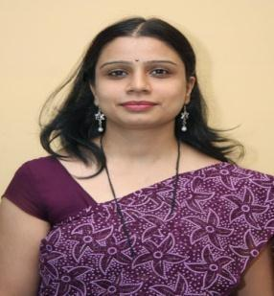

* Name : Dr. Manasi Sameer Bhate
* Designation : Professor
* Date of Birth : 24/04/1977
* Unique ID : 1-453866555
* Education Qualifications : B Sc, MCM, MCA, Ph D

###### Work Experience

Teaching : 23

Research : 10

Industry : NIL

others : NIL

Area of Specialization : HR, Information Technology ,

Courses taught : Management Fundamentals, Sales and distribution Management PM OB, OOAD

###### Research guidance (Number of Students)

Master (Completed/Ongoing) 16

Ph.D. (Completed/Ongoing) : 1/5 Projects Carriedout : NIL

No. of papers published in

National: NIL International Journals: 19 Conferences: 3 Patents (Filed & Granted) : 01 Patent Filed

Technology Transfer : NIL

No. of Books published with details : NIL

(Name of the book, Publisher with ISBN, year of publication, etc.)

* Name: Dr. Ravikant Zirmite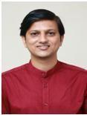
* Designation : Professor
* Date of Birth: 10/07/1983
* Unique ID : 1-453866681
* Education Qualifications : BCA, MCA, PhD

###### Work Experience

Teaching : 14 Years Research : NIL Industry : NIL

others : NIL

Area of Specialization : Programming

Courses taught : Post Graduate- Python, Node JS, Angular JS, Web Technologies, Data Structure and Algorithm, Object Oriented Programming, .NET

* **Research guidance (Number of Students)** Master (Completed/Ongoing) : NIL Ph.D. (Completed/Ongoing) :4 Projects Carriedout :

No. of papers published in

National: NIL International Journals: 16 Conferences: NIL Patents (Filed & Granted) :

Technology Transfer : NIL

No. of Books published with details :

(Name of the book, Publisher with ISBN, year of publication, etc.)

* Name Dr. Shweta Meshram
* Designation : Associate Professor
* Date of Birth 06/06/1983
* Unique ID : 1-2183524792
* Education Qualifications : B.Sc MCA Ph.D

###### Work Experience

Teaching : 15 Years

Research : NIL

Industry : 02. 5 Years

others : NIL

Area of Specialization : Data Mining

Courses taught : Post Graduate : DMW, ADBMS, Core java, DBMS, Information Security and Audit.

* **Research guidance (Number of Students)** Master (Completed/Ongoing) : NIL Ph.D. (Completed/Ongoing) : NIL Projects Carried Out :

No. of papers published in

National: NIL International Journals: 09 Conferences: 03 Patents (Filed & Granted) :

Technology Transfer :

No. of Books published with details :

(Name of the book, Publisher with ISBN, year of publication, etc.)

* Name : Dr. Venugopal Shankaraiah Narsingoju 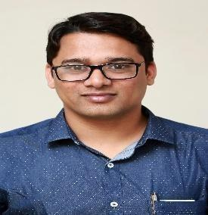
* Designation : Associate Professor
* Date of Birth : 25/04/1984
* Unique ID : 1-3175934642
* Education Qualifications: B. Sc. MCA, M.Phil. B. Ed. Ph.D.

###### Work Experience

Teaching: 16 years

Research: -- NIL

Industry: -- NIL

others : -- NIL

Area of Specialization: Cloud Computing Courses taught : Java, Python

* **Research guidance (Number of Students)** Master (Completed/Ongoing) : NIL Ph.D. (Completed/Ongoing) : NIL Projects Carried Out:

No. of papers published in

National: 05 International Journals: 13 Conferences: Patents (Filed & Granted): Filed : 02

Technology Transfer: NIL

No. of Books published with details: 02

Name of the Book: “Impacts of Cloud Computing on Enterprises focused on Security and Cost”, Publisher with ISBN: LAP Lambert Academic Publishing, Mauritius, ISBN: 978-3-659-68841-6 year of publication: September 2018

* Name : Dr. Shilpa Shailesh Parlikar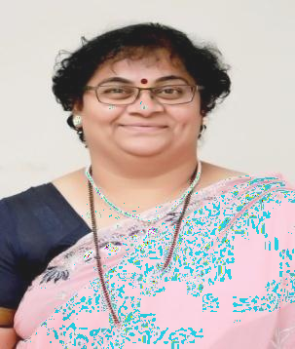
* Designation : Assistant Professor
* Date of Birth : 4th October 1969
* Unique ID : 1-453866551
* Education Qualifications : B.Sc.,ADCSSAA, M.C.M., Ph.D. Done “**ITIL Expert**” International Certification

###### Work Experience

Teaching : 24 Years

Research : 4 Years

Industry : NIL

others : NIL

Area of Specialization : Programming Languages. Courses taught : Mobile Application Development, Java, Project.

###### Research guidance (Number of Students)

Master (Completed/Ongoing) : 1

* Ph.D. (Completed/Ongoing) : NIL Ongoing Projects Carried Out : NIL. No. of papers published in

National: 06 International Journals: NIL Conferences: NIL Patents (Filed & Granted) :

Technology Transfer :

No. of Books published with details : -

(Name of the book, Publisher with ISBN, year of publication, etc.)

* Name Dr. Jayashree Swapnil Patil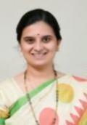
* Designation : Assistant Professor
* Date of Birth 9th April 1980
* Unique ID : 1-453866665
* Education Qualifications : MCA, PhD

###### Work Experience

Teaching : 20 Years

Research : 3

Industry : NIL

others : NIL

Area of Specialization : Customer Relationship Management, Artificial Intelligence.

Courses taught : Object Oriented Software Engineering, Artificial Intelligence,

Optimization Techniques

* **Research guidance (Number of Students)** Master (Completed/Ongoing) : NIL Ph.D. (Completed/Ongoing) : 1 Projects Carriedout : NIL

No. of papers published in

National: 02 International Journals: 03 Conferences: 1 Patents (Filed & Granted) : Granted 01

Technology Transfer :

No. of Books published with details : -

(Name of the book, Publisher with ISBN, year of publication, etc.)

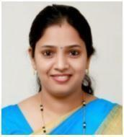

* Name: Dr. Ashwini Subhash Patil
* Designation : Assistant Professor
* Date of Birth: 07/11/1982
* Unique ID : 1-453866567
* Education Qualifications : BCS, MCA, PhD

###### Work Experience

Teaching : 16 Years

Research : 04 years

Industry : NIL

others :

Area of Specialization : Programming

Courses taught : Data Structure and Algorithms, Python Programming

* **Research guidance (Number of Students)** Master (Completed/Ongoing) : NIL Ph.D. (Completed/Ongoing) 1
* Projects Carried out : NIL No. of papers published in

National: 01 International Journals: 02 Conferences: 02 Patents (Filed & Granted) :

Technology Transfer : NIL

No. of Books published with details :

(Name of the book, Publisher with ISBN, year of publication, etc.)

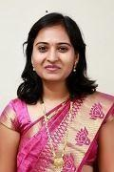

* Name : Dr. Minakshi Mukesh More
* Designation : Assistant Professor
* Date of Birth : 30/04/1985
* Unique ID : 1-782955435
* Education Qualifications : B.Sc.,M.C.A, Ph.D.(Computer Science)

###### Work Experience

Teaching : 14 Years

Research : 2011 To Till.

Industry : NIL

others : 1. Worked as a Peer Reviewer of the 8th International Conference on Data Management, Analytics and Innovation (ICDMAI 2024) to be held in VIT, Vellore, India from 19-21 January 2024

2. Contributed as a Judge for the paper presentations for the International Conference on “Nurturing

Innovations in an Organization.” to be held in MES IMCC, Pune on 15 th &amp; 16 th February 2024.

Area of Specialization: Computer Application Courses taught : ADBMS, DW&amp; DW.

* **Research guidance (Number of Students)** Master (Completed/Ongoing) : NIL Ph.D.

(Completed/Ongoing) : 3 Ongoing

* Ongoing Projects Carried Out : NIL No. of papers published in

National: 03 International Journals: 06 Conferences: 4 Scopus: 2 Patents Technology Transfer : NIL

No. of Books published with details : 1 Book Name “Digital Image Processing”

Publisher with ISSN: 978-93-5757-525-6, Scientific International Publishing House Year of publication: 2023

Website Link: Scientific International Publishers (sipinternationalpublishers.com)

(Name of the book, Publisher with ISBN, year of publication, etc.)

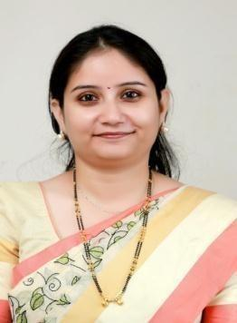

* Name: Mrs. Darshana Prasad Yadav
* Designation : Assistant Professor
* Date of Birth: 05 July 1982
* Unique ID: 1-453866583
* Education Qualifications: B.Sc. (Electronics), MCA (Management)

###### Work Experience

Teaching : 14 Years & 6 Months. Research : NIL

Industry : 02 years

Others :NIL Area of Specialization:

Courses taught : OSC, DBMS, STQA, Computer architecture.

* **Research guidance (Number of Students)** Master (Completed/Ongoing) : NIL Ph.D. (Completed/Ongoing) :
* Projects carried out:

No. of papers published in

National: NIL International Journals: NIL Conferences: NIL Patents (Filed & Granted):

Technology Transfer:

No. of Books published with details:

(Name of the book, Publisher with ISBN, year of publication, etc.)

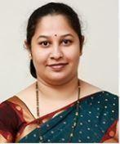

* Name : Dr. Swapnaja Sameer Patwardhan
* Designation : Assistant Professor
* Date of Birth : 24th Jan 1979
* Unique ID : 1-1493411979
* Education Qualifications : B.Sc.,M.C.A., M.Phil., Ph.D.

###### Work Experience

Teaching : 18 Years

Research : 16 Years

Industry : 02 Years

others : Work as a reviewer

Area of Specialization : Data Mining, Data Science, AI, ML Courses taught : Business Statistics, KRAI, Software Engineering

* **Research guidance (Number of Students)** Master (Completed/Ongoing) : NIL Ph.D. (Completed/Ongoing) : NIL Projects Carried Out :

No. of papers published in

National: 03 International Journals: 08 Conferences: 06 Patents (Filed & Granted) : 01 - Granted

Technology Transfer : NIL

No. of Books published with details :

(Name of the book, Publisher with ISBN, year of publication, etc.)

###### Profile of the Faculty

* + Name Mrs. Apurwa Abhijjeet Barve
  + Designation : Assistant Professor
  + Date of Birth 13th February 1982
  + Unique ID : 1-2183441067
  + Education Qualifications : MCA, BSc (Comp Science)

###### Work Experience

Teaching : 10 Years 6 months Research : NIL

Industry : 07 years

others : - NIL Area of Specialization :

Courses taught : Java, Advanced Java, C programming, OOA, Advance Internet Technologies.

* + **Research guidance (Number of Students)** Master (Completed/Ongoing) : - NIL Ph.D. (Completed/Ongoing) : - NIL Projects Carriedout : -

No. of papers published in

National: 02 International Journals: NIL Conferences: 02 Patents (Filed & Granted) :

Technology Transfer :

No. of Books published with details :

(Name of the book, Publisher with ISBN, year of publication, etc.)



###### Work Experience

Teaching : 11 years

Research : NIL

Industry : NIL

others : NIL Area of Specialization :

Courses taught : Cloud Computing, Software Project Management.

* **Research guidance (Number of Students)** Master (Completed/Ongoing) : NIL Ph.D. (Completed/Ongoing) : NIL Projects Carried Out :

No. of papers published in

National: 04 International Journals: 01 Conferences: Patents (Filed & Granted) :

Technology Transfer : NIL

No. of Books published with details : -

(Name of the book, Publisher with ISBN, year of publication, etc.)

* 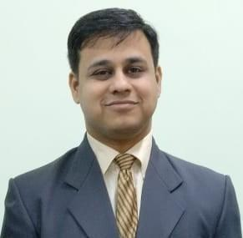Name: Dr. Mukul Laxmankumar Kulkarni
* Designation : Assistant Professor
* Date of Birth: 11/07/1986
* Unique ID: 1-2183440939
* Education Qualifications: B.Sc., M.C.A., M.B.A, Ph.D.

###### Work Experience

Teaching : 11 Years

Research : NIL

Industry : 2 Years

others : NIL

Area of Specialization: Machine Learning and Data Science Courses taught : Optimization Techniques, Computer Networks

* **Research guidance (Number of Students)** Master (Completed/Ongoing) : NIL Ph.D. (Completed/Ongoing) : 1 Projects Carried Out: Ongoing: 01

No. of papers published in

National: 02 International Journals: 06 Conferences: 01 Patents (Filed & Granted): Filed - 03

Technology Transfer:

No. of Books published with details:

(Name of the book, Publisher with ISBN, year of publication, etc.)

* Name: Ms. Manasi Shirurkar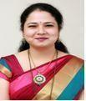
* Designation : Assistant Professor
* Date of Birth: 02/10/1987
* Unique ID: 1-2183357158
* Education Qualifications: BCS, MCA

###### Work Experience

Teaching : 12 Years

Research : 2 Years

Industry : NIL

Others : NIL

Area of Specialization: Cyber Security.

Courses taught :Operating Systems, Software Engineering, Networking, Software Project Management

###### Research guidance (Number of Students)

Master (Completed/Ongoing) : NIL Ph.D. (Completed/Ongoing) : NIL Projects carried out:

No. of papers published in

National: 02 International Journals: 3 Conferences: NIL Patents (Filed & Granted) :

Technology Transfer :

No. of Books published with details :

(Name of the book, Publisher with ISBN, year of publication, etc.)

* Name Ms. Dipti Narendra Belsare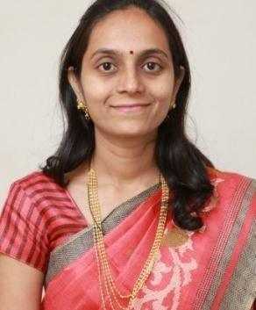
* Designation : Assistant Professor
* Date of Birth 06/02/1982
* Unique ID : 1-2183525182
* Education Qualifications : B.Sc, MCA, PhD (Pursuing)

###### Work Experience

Teaching : 16 Years

Research : NIL

Industry : 01 Year

others : NIL

Area of Specialization : Programming, Database, and Web Technologies Courses taught : Post Graduate

* **Research guidance (Number of Students)** Master (Completed/Ongoing) : NIL Ph.D. (Completed/Ongoing) : NIL Projects Carriedout : NIL

No. of papers published in

National: 01 International Journals: 02 Conferences: Patents (Filed & Granted) : 01 Filed

Technology Transfer : NIL

No. of Books published with details : NIL

(Name of the book, Publisher with ISBN, year of publication, etc.)

# Profile of the Faculty

* Name : Akshay Ashok Moralwar 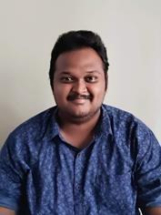
* Designation : Assistant Professor
* Date of Birth : 31/05/1994
* Unique ID : 1-44236789454
* Education Qualifications: Master of Computer Applications

###### Work Experience

Teaching: 6.4 years

Research: -- NIL

Industry: -- 6.4

others : -- NIL

Area of Specialization: Java, Spring MVC, Spring boot, Angular, MySQL, Oracle. Courses taught: Project Guidance, Mock Interviews.

* **Research guidance (Number of Students)** Master (Completed/Ongoing) : NIL Ph.D. (Completed/Ongoing) : NIL Projects Carried Out:

No. of papers published in

National: International Journals: Conferences: Patents (Filed & Granted): Filed :

Technology Transfer: NIL

No. of Books published with details:

Name of the book, Publisher with ISBN, year of publication, etc.

###### Profile of the Faculty

* Name Mr. Ajay Ankush Pacharne
* Designation: Assistant Professor
* Date of Birth: 01/07/1985
* Unique ID : 1-44236493941
* Education Qualifications: MCA,
* Work Experience Teaching: 5 Years

Research : NIL

Industry : NIL

others : NIL Area of Specialization :

Courses taught : Post Graduate

* **Research guidance (Number of Students)** Master (Completed/Ongoing) : NIL Ph.D. (Completed/Ongoing) : NIL Projects Carried Out : NIL

No. of papers published in

National: NIL International Journals: NIL Conferences: NIL Patents (Filed & Granted) :

Technology Transfer :

No. of Books published with details :

(Name of the book, Publisher with ISBN, year of publication, etc.)

## Profile of the Faculty

* Name : Dr. Girish Ashok Bodhankar



* Designation : Associate Professor
* Date of Birth: 03 December 1989
* Unique ID: 1-7366352393
* Education Qualifications: PhD (Business Administration), MBA (Finance)

###### Work Experience

Teaching: 10 Years Research: NIL

Industry: 01 Year

Others : NIL

Area of Specialization: Finance

Courses taught: Post Graduate

* **Research guidance (Number of Students)** Master (Completed/Ongoing) : NIL Ph.D. (Completed/Ongoing) : NIL Projects Carried out:

No. of papers published in

National: 10 International Journals: NIL Conferences: NILPatents Patents (Filed & Granted): NIL

Technology Transfer: NIL No. of Books published with details: 04

###### Profile of the Faculty

* Name : Dr. Poonam Shripad Vatharkar
* Designation: Assistant Professor
* Date of Birth : 25 October 1983
* Unique ID : 1- 7468872589
* Education Qualifications: **Ph.D.**(Organizational Behaviors & Human Resource Management),

**M.Phil.** (Human Resource Management), **MBA** (Human Resource Management), **B. Com.**

###### Work Experience

Teaching: 09 Years Research: NIL

Industry: 05 Years Others :

Area of Specialization: Organizational Behavior & Human Resource Management Courses taught :

Organizational Behavior, Business Research Methods, Competency-based HRM Human Resource Management, Contemporary Frameworks in Management HR Operations, Organizational Diagnosis &amp; Development

###### Research guidance (Number of Students)

Master (Completed/Ongoing) : NIL Ph.D. (Completed/Ongoing) : NIL

###### Projects carried out: (completed)

* + Worked on a Research Project titled “Women Entrepreneurship in Small Scale Sector –
  + Constraints &amp; Motivating Factors” ( Proposal No. 11MGM000482) which has received a
  + grant of Rs.2,00,000/- for UGC Research Grant scheme under B.C.U.D., Savitribai Phule
  + Pune University.
* **No. of papers published in**

National: International Journals: 14 Conferences: 04 Patents (Filed & Granted) : NIL

Technology Transfer :

###### Awards &amp; Distinctions

Best Paper Award – Won “Best Paper Award” for the research paper on “Impact of Cybervictimization on Perceived Self-image and Social Anxiety – Mediating Role of Emotional Intelligence” presented at the International Conference on “Nurturing Innovations in an

Organization” organized on 15th and 16th February 2024.

Presented a paper at the British Academy of Management Conference, 2022 (BAM 2022) held

in Manchester, United Kingdom from 31st August to 2nd September 2022 hosted by Alliance Manchester Business School, University of Manchester.

Indian Academy of Management (INDAM) Research Workshop, New Delhi – Participated in Research Workshop conducted by INDAM (an affiliate of Academy of Management, USA and Indian Institute of Management, Ahmedabad, IIM-A) on 6-7th January 2020 and won FIRST PRIZE for the research poster presented. (Certificate + Rs. 25000/- cash prize)

Best Paper Award – Won second “Best Paper Award” for the research paper on “Challenges in Talent Retention” presented at the International Conference on Talent Management organized by Bharati Vidyapeeth IMED

Member of Editorial Board – International Journal of Business and Economics Research (IJBER)

Research Journals Reviewers Panel – Working as a reviewer for the South Asian Journal of Business Studies &amp; Business Perspective &amp; Review (Scopus Index and ABDC category Journal)

Avishkar Review Panel – Working as a Reviewer on the review panel of the AVISHKAR State Level Research Competition of Savitribai Phule Pune University

###### Association with Professional Bodies

British Academy of Management (BAM)

Indian Academy of Management (INDAM -An affiliate of Academy of Management, USA) National Institute of Personnel Management (NIPM)

ISTE Membership

###### Any other Achievements

Master Practitioner of Appreciative Inquiry Certified Psychometric Test Professional Certified Behavioral Trainer

* Name: Dr.Harshada Jeetendra Raut
* Designation: Assistant Professor Photo (Passport size)
* Date of Birth:25/11/1985
* Unique ID: 1-43458667011
* Education Qualifications: B.E, MBA, Ph.D.
* **Work Experience** Teaching: 7 Research:4 Industry:3

NIL

others:

Area of Specialization: Operation and Marketing

Courses taught: BRM, Marketing, Operations, Strategic Management

###### Research guidance (Number of Students)

Master (Completed/Ongoing) : 35

Ph.D. (Completed/Ongoing) : -Ongoing Projects Carried out: -0

No. of papers published in

National: 8 International Journals: 3 Conferences: 4 Technology Transfer:

No. of Books published with details: 1

(Name of the book, Publisher with ISBN, year of publication, etc.)

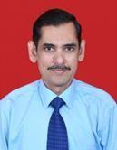

* Name : Dr. Hemant Baliram Patil
* Designation: Assistant Professor
* Date of Birth: 19/05/1973
* Unique ID: 1-43458667160
* Education Qualifications: BE, MBA, PhD
* Work Experience Teaching:

15 Years Research:

NIL

Industry:

11 years 3 months others:

Area of Specialization: Marketing

Courses taught: Basics of Marketing, Marketing Strategy, Marketing Management, Strategic Brand Management, Consumer Behavior, Services Marketing, Sales and Distribution Management, Selling &amp; Negotiation Skills, Customer Relationship Management, Marketing Research, Marketing 4.0, Economic Analysis for Business Decisions

* Research guidance (Number of Students) Master (Completed/ Ongoing) : 210

Ph.D. (Completed/ Ongoing) : NA Ongoing Projects Carried out: Nil No. of papers published in

National: 3 International Journals: 6 Conferences: 5 Technology Transfer: Nil

No. of Books published with details: Nil

(Name of the book, Publisher with ISBN, year of publication, etc.)

#### Profile of the Faculty

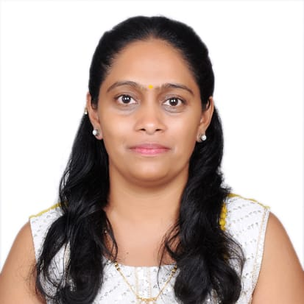

* Name : Dr. Archana Hrushikesh Patil
* Designation: Assistant Professor
* Date of Birth: 30/12/81
* Unique ID: 1-43459227752

#### Education Qualifications:

P.hd Awarded in SPPU (SIBACA Lonavala) | Titled: ***An analytical study of CSR activities in MNC in Pune District*** | Pune 2021

MBA (**Human Resource Management & Financial Management**) | Pune | 2009 | SPPU| 1st class (61%) B.Sc (**Zoology**) |Pune |2006| SPPU | 1st class with Distinction (72%)

###### HR Analytics IIM Rothak 2021

Behavioral Assessment workshop (4 days) |online | 16PF, Transactional Analysis N5 level Japanese language

Handwriting Analysis

#### Work Experience

Teaching: 15+ years

Research: 8 papers

Industry: 3 years others:

Area of Specialization: Organization Management Courses taught: MBA

#### Research guidance (Number of Students)

##### Master (Completed/Ongoing) :

Ph.D. (Completed/Ongoing) : Completed Ongoing Projects Carried out:

##### No. of papers published in

National: 8 International Journals: 3 Conferences: Technology Transfer:

No. of Books published with details: 2

(Name of the book, Publisher with ISBN, year of publication, etc.)

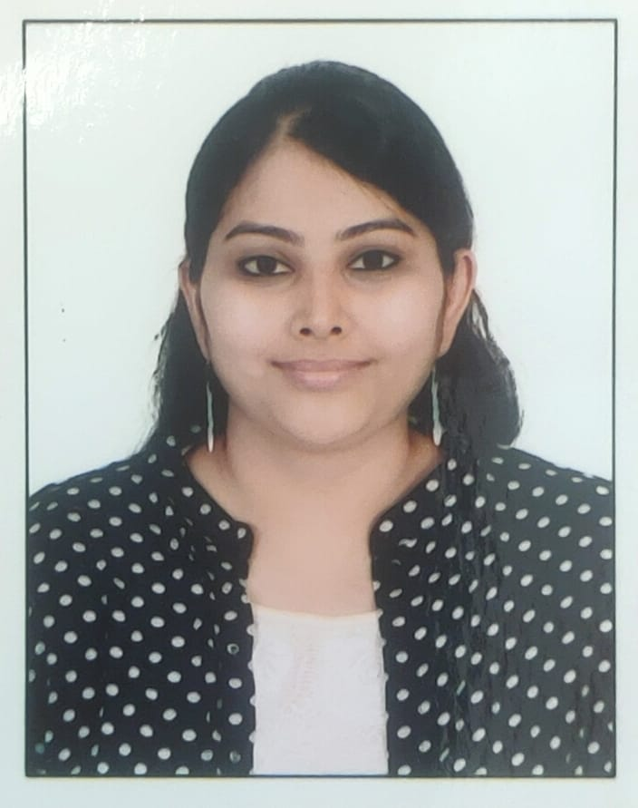

* Name : Aarti Deshpande
* Designation: Assistant Professor
* Date of Birth: 14/08/1990
* Unique ID: 1-43459227959
* Education Qualifications: BE E&TC, MBA HR, NET, SET

#### Work

**Experience** Teaching:

1 year Research: NIL Industry: 7 years others:

Area of Specialization: HR Courses taught:

# Research guidance (Number of Students) NIL

Master (Completed/Ongoing) : NIL

Ph.D. (Completed/Ongoing) : No Ongoing Projects Carried out: NIL No. of papers published in

National: NIL International Journals: NIL Conferences: NIL

Technology Transfer: NIL

No. of Books published with details: NIL

(Name of the book, Publisher with ISBN, year of publication, etc.)

* Name: Ms. Ashwini Prabhakar Chavan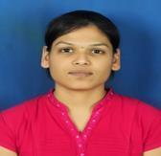
* Designation: Assistant Professor
* Date of Birth: 08/08/1989
* Unique ID: 1-7324096529
* Education Qualifications: Ph.D (pursuing), MBA(Finance),BBA(Marketing), NTA UGC NET Qualified.

#### Work Experience

Teaching: 5 Years

Research: 00

Industry: 5 Years

Others:

Area of Specialization: Finance & Marketing

Courses taught: Basics of Marketing, Management Fundamentals, Marketing Management, Business Process Outsourcing, Financial Markets & Banking Operations, Strategic Management, Financial Laws, Services marketing,

# Research guidance (Number of Students)

[Master (Completed/Ongoing) 52](#_heading=h.49x2ik5)

Ph.D. (Completed/Ongoing) : Ongoing Projects Carried out:

[No. of papers published in](#_heading=h.2p2csry)

National: 4 International Journals: 2 Conferences: 1

Technology Transfer: NIL

No. of Books published with details: NIL

(Name of the book, Publisher with ISBN, year of publication, etc.)

#### Profile of the Faculty

* Name : Dr. Shilpa Ashwinikumar Buche
* Designation: Assistant
* Date of Birth: 09/06/1978
* Unique ID: 1-44236493774
* Education Qualifications: B.com, MBA in Finance and Marketing and PhD in Finance

#### Work Experience

Teaching: 6.6 years

Research: 10 years

Industry: 6 years NIL others:

Area of Specialization: Finance and Marketing Courses taught:

#### Research guidance (Number of Students)

Master (Completed/Ongoing) : 100 students Ph.D. (Completed/Ongoing) : Ongoing Projects Carried out:

No. of papers published in

National:2 International Journals: 6 Conferences:

Technology Transfer:

No. of Books published with details:

(Name of the book, Publisher with ISBN, year of publication, etc.)

# Profile of the Faculty

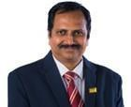

* Name : Dr. Ashish Krishna Vyas
* Designation: Assistant Professor
* Date of Birth: 13/07/1971
* Unique ID: 1-402093481
* Education Qualifications: Ph.D., MBS (HR), PGDBM (HR), B.E. (I.E.), Naturopathy Diploma.

#### Work Experience

Teaching: 27 years

Research: 06 years and 5 months. Researcher for the project of Rotary Club of midtown Pune. Research Guide under SPPU.

Industry: 10 years

others: Worked as: Research Center Head, Yoga Teacher, Managing Council member for NIPM & ISTD, Secretary and Treasurer for ISTD, Career Counseling, Mentor for students, IQAC Coordinator etc.

Area of Specialization: Human Resource Management

Courses taught: Organizational Behavior, Human Resource Management, Legal Aspects of Business, Business Research Methodology, Labour Laws, Competency based HRM system, Strategic Management, Indian Ethos and Business Ethics,

# Research guidance (Number of Students)

Master (Completed/Ongoing) : 130 Completed. Ph.D.(Completed/Ongoing) : 02 Ongoing.

Ongoing Projects Carried out: Nil No. of papers published in

National: 11 International Journals: 02 , and 12 UGC care Conferences: 11 Technology Transfer: Nil

No. of Books published with details: 03

(Name of the book, Publisher with ISBN, year of publication, etc.)

|  |  |  |  |  |
| --- | --- | --- | --- | --- |
| **Sr.No** | **Author Name** | **Book** | **Year** | **Publisher** |
| 1 | Ashish Vyas | Accounting for Business Decisions ISBN No.978-93-82249-00- 9 | 2013 | Thakur Publication |
| 2 | Ashish Vyas | Accounting for Business Decisions ISBN No.978-81- 932613-5-4 | 2016 | Thakur Publication |
| 3 | Ashish Vyas | Organizational Behaviour ISBN 978-93-88809-79-5 | 2019 | Thakur Publication |

**Profile of the Faculty**

* Name : Ms. Jaee Jogalekar
* Designation: Assistant Professor
* Date of Birth: 25/09/1997
* Unique ID: 1-44236417294
* Education Qualifications: BHMCT, MBA (HR + Marketing)

###### Work Experience

Teaching: 1.8 Years

Research: 1.8 Years

Industry: 1 Year NIL others:

Area of Specialization: Human resource & marketing management

Courses taught: Basics of Marketing, Training & Development, Consumer Behavior, Marketing Management, Human Resource Management.

# Research guidance (Number of Students)

**Master (Completed/Ongoing) : Completed (MBA from PUMBA, Nashik in HR & marketing Ph.D.** (Completed/Ongoing) : N/A

###### Ongoing Projects Carried out: Nill

**No. of papers published in**

**National:** 1 **International Journals**: 11 **Conferences**: 2 Technology Transfer: Nill

**No. of Books published with details**: 1 Book Published

Details: ‘Innovation & Entrepreneurship for Sustainable Growth’ , Scientific International Publication House, ISBN : 978- 93-5625-287-5, 2022.

**No of International case Studies Published**: 1 Case Study Published Details: Case Study Published in The Case Centre, Britain on ‘Kandoi Bhogilal Mulchand- Retail Management Framework’ Ref no: 523-0044-1 (May 2023).

Name: Sonali Dilip Kulkarni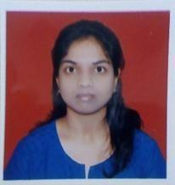

Designation: Assistant Professor

* Date of Birth: 18/01/1992
* Unique ID: 1-43459485260
* Education Qualifications: MBA
* **Work Experience** Teaching: 2 Research
* : Industry: 3 Years

Area of Specialization: Finance Courses taught: MBA

# Research guidance (Number of Students)

Master (Completed/Ongoing) : NA

Ph.D. (Completed/Ongoing) : NA

Ongoing Projects Carried out: NA No. of papers published in

National: Nil International Journals: Nil Conferences: Nil

Technology Transfer: Nil

No. of Books published with details: Nil

(Name of the book, Publisher with ISBN, year of publication, etc.)

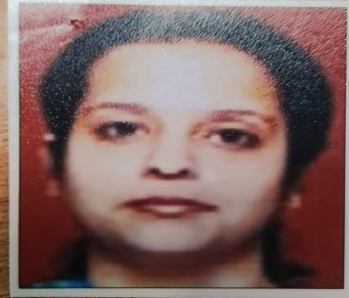

* Name: Maitreyee Phadnis Designation: Assistant Professor
* Date of Birth: 30/01/986
* Unique ID: 1-43458667186
* Education Qualifications: MBA
* **Work Experience** Teaching: 11
* Research :
* : Industry: NIL

Area of Specialization: Finance Courses taught: MBA

# Research guidance (Number of Students)

Master (Completed/Ongoing) : NA

Ph.D. (Completed/Ongoing) : NA Ongoing Projects Carried out: NA

No. of papers published in

National: Nil International Journals: Nil Conferences: Nil Technology Transfer: Nil

No. of Books published with details: Nil

(Name of the book, Publisher with ISBN, year of publication, etc.)

* Name: Mansi Santosh Hinduja Designation: Assistant Professor
* Date of Birth: 14/10/1993
* Unique ID: 1-43459227468
* Education Qualifications: MBA
* **Work Experience** Teaching: 3
* Research :
* : Industry: NIL

Area of Specialization: Finance Courses taught: MBA

# Research guidance (Number of Students)

Master (Completed/Ongoing) : NA

Ph.D. (Completed/Ongoing) : NA

Ongoing Projects Carried out: NA No. of papers published in

National: Nil International Journals: Nil Conferences: Nil

Technology Transfer: Nil

No. of Books published with details: Nil

(Name of the book, Publisher with ISBN, year of publication, etc.)

* + Name : Tagare Mohisha Mohan 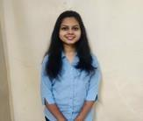
* Designation: Assistant Professor
* Date of Birth: 03/07/1998
* Unique ID: 1-44236146284
* Education Qualifications: MBA in Financial Management.

###### Work Experience

* Teaching: NIL
* Research:

Industry: 6 months in banking and 2 months in IT Others: NIL Area of Specialization: FINANCIAL MANAGEMENT

Courses taught: NIL

# Research guidance (Number of Students)

Master (Completed/Ongoing) : NIL

Ph.D. (Completed/Ongoing) : NIL Ongoing Projects Carried out : NIL

No. of papers published in

National: NIL International Journals: NIL Conferences: NIL

Technology Transfer: NIL

No. of Books published with details: NIL

(Name of the book, Publisher with ISBN, year of publication, etc.)

* Name : Prajakta Sanjay Kulkarni
* Designation: Assistant Professor



* Date of Birth: 08/05/2000
* Unique ID: 1-44236198684
* Education Qualifications: MBA finance

###### Work Experience

Teaching:

* Research: NIL
* Industry: 6month in Taxation and 1 years in Financial analyst.
* Others:NIL

Area of Specialization: FINANCIAL MANAGEMENT Courses taught: NIL

# Research guidance (Number of Students)

Master (Completed/Ongoing) : Completed.

Ph.D. (Completed/Ongoing) : NIL

Ongoing Projects Carried out: NIL No. of papers published in

National: NIL International Journals: NIL Conferences: NIL

Technology Transfer: NIL

No. of Books published with details:

(Name of the book, Publisher with ISBN, year of publication, etc.)

* Name : Kaustubh Raghunath Purohit
* Date of Birth: 01/09/1986
* Designation: Assistant Professor
* Unique ID: 1-44236146343
* Education Qualifications: MBA

###### Work Experience

* Teaching:
* Research: NIL

· Industry: NIL Others:NIL

Area of Specialization:

Courses taught: NIL

* Research guidance (Number of Students) Master (Completed/Ongoing) :

Ph.D. (Completed/Ongoing) : NIL Ongoing Projects Carried out: NIL No. of papers published in

National: NIL International Journals: NIL Conferences: NIL

Technology Transfer: NIL

No. of Books published with details:

(Name of the book, Publisher with ISBN, year of publication, etc.)

* Name : Ms. Dhanashree Sudhir Utturkar
* Date of Birth: 03/01/1991
* Designation: Assistant Professor
* Unique ID: 1-44236146511
* Education Qualifications: MBA

###### Work Experience

* Teaching:
* Research: NIL

· Industry: NIL Others:NIL

Area of Specialization:

Courses taught: NIL

* Research guidance (Number of Students) Master (Completed/Ongoing) :

Ph.D. (Completed/Ongoing) : NIL Ongoing Projects Carried out: NIL No. of papers published in

National: NIL International Journals: NIL Conferences: NIL

Technology Transfer: NIL

No. of Books published with details:

(Name of the book, Publisher with ISBN, year of publication, etc.)

* Name : Mr. Anup Mukund Badve
* Date of Birth: 31/07/1982
* Designation: Assistant Professor
* Unique ID: 1-43463987691
* Education Qualifications: MBA

###### Work Experience

* Teaching:
* Research: NIL

· Industry: NIL Others:NIL

Area of Specialization:

Courses taught: NIL

* Research guidance (Number of Students) Master (Completed/Ongoing) :

Ph.D. (Completed/Ongoing) : NIL Ongoing Projects Carried out: NIL No. of papers published in

National: NIL International Journals: NIL Conferences: NIL

Technology Transfer: NIL

No. of Books published with details:

(Name of the book, Publisher with ISBN, year of publication, etc.)

|  |  |  |
| --- | --- | --- |
| 18.9 | **Fee** |  |
| i | No. of Fee waivers granted with amount and | MCA-I : 09 TFWS students x 141000/- = 12,69,000/- |
| name of student | MCA -II : 08 TFWS students x 1,34,000/- = 10,72,000/-  MBA -I : 09 TFWS students x 1,20,000/- = 10,80,000/- |
| MBA -II :07 TFWS student x 1,08,000/- = 7,56,000/- |
| **Total : 33 Total : 41,77,000/-** |

|  |  |  |
| --- | --- | --- |
|  |  | Details of TFWS beneficiary Students |
| **MCA- I** |
| 1. ROKADE OMKAR DILIP 2. SAYYAD SAIFAN GAFAR 3. NARAWADE PRITI SUBHASH 4. KADAMBA VANDITH VASANT 5. HIRE VAIBHAVI ARVIND 6. KETAN SANJAY NIVANGUNE 7. ZEBA TANVEER SAYYED MANZOOR AHMED 8. MOHIT HARIBHAU FULKAR 9. GAHERWAR POONAM ANANTSINGH |
| **MCA - II** |
| 1. KRUSHNA SANTOSH CHAUDHARI 2. NARESH PRAKASH JOSHI 3. GAURAV SUNIL BANGADE 4. PRANJAL PRAKASH SHINTRE 5. VIRESH NANDKUMAR HIREMATH 6. VIVEK YESHVANT MORE 7. SANKET JANARDHAN MANE 8. VAIBHAV KAILAS RAUT |
| **MBA - I** |
| 1. ATHARVA SACHIN CHAUDHARI 2. BHARATWANSHI CHANCHAL GANESH 3. BHAVE VAIDEHI SUHAS 4. BHANUSHALI DHRUV KANAHYALAL 5. SURYAWANSHI TANMAY LALIT 6. DESHMUKH VAISHNAVI PRFULLA 7. DIWAN JAYRAJ MADHAV 8. SHRUTI FANDAT 9. DUDHANE UTKARSH BALASAHEB |
|  |  | **MBA – II**   1. AJAY SANDESH MEHTA 2. SUJAY SANDESH MEHTA 3. AKSHAY SURESH PATIL 4. YASH YOGESH BHAT 5. NEHA NARENDRA PATIL 6. PRATIKSHA DESHMUKH 7. SUJIT BHARATKUMAR MANE |

|  |  |  |  |  |  |  |  |  |  |  |  |  |  |  |  |  |  |
| --- | --- | --- | --- | --- | --- | --- | --- | --- | --- | --- | --- | --- | --- | --- | --- | --- | --- |
| ii | Number of scholarship offered by the Institution, duration and amount | | | | | | | https://mahadbt.maharashtra.gov.in/login/login  10 types of Scholarship/Freeship offered by the Institute as per State Government Mahadbt scholarship Criteria  Duration: 2 Years  Benefit of Amount: 3,28,21,086/- ( A.Y. 2023 - 24) SC/ST Category : Tuition Fee+ Devl. Fee VJ/NT/SBC Category: Tuition Fee OBC/EWS/EBC Category: 50% of Tuition Fee | | | | | | | | | |
| 18.10 | **Admission** | | | | | | |  | | | | | | | | | |
| i | Number of seats sanctioned with the year of approval | | | | | | | 2023-24 :  MCA 180 Intake  MBA 180 Intake | | | | | | | | | |
| ii | Number of Students admitted under various categories each year in the last three years | | | | | | | | | | | | | | | | |
|  |  | | | | **2021 - 22** | | | | **2022 - 23** | | | | | **2023 - 24** | | | |
|  |  | | | | **MCA** | | **MBA** | | **MCA** | | | **MBA** | | **MCA** | | **MBA** | |
|  | Year wise sanctioned Intake | | | | 120 | | 60 | | 180 | | | 180 | | 180 | | 180 | |
|  | Year wise actual admission | | | | 120 | | 59 | | 180 | | | 180 | | 179 | | 178 | |
|  | Number of Students admitted under various categories each year in the last three years | | | | | | | | | | | | | | | | |
|  | **Year** | **OPEN** | | **SC** | | | **ST, OBC, VJ, NT, DT, SBC** | | | | | | **Total Admitted** | | | | |
|  |  | **MCA** | **MBA** | **MCA** | | **MBA** | **MCA** | | | **MBA** | | | **MCA** | | | **MBA** | |
|  | **2021-22** | 60 | 42 | 13 | | 4 | 47 | | | 13 | | | 120 | | | 59 | |
|  | **2022-23** | 89 | 107 | 17 | | 18 | 74 | | | 55 | | | 180 | | | 180 | |
|  | **2023-24** | 90 | 103 | 24 | | 21 | 65 | | | 54 | | | 179 | | | 178 | |
|  |  |  |  |  | |  |  | | |  | | |  | | |  | |
| iii | Number of applications received during last two years for admission under Management Quota and number admitted | | | | | **Management Quota** | | | | | **2022 - 23** | | | | **2023 - 24** | | |
| **MCA** | | **MBA** | | **MCA** | | **MBA** |
| Application received | | | | | 36 | | 36 | | 36 | | 36 |
| Admitted | | | | | 36 | | 36 | | 36 | | 36 |
| 18.11 | **Admission Procedure** | | | | | | |  | | | | | | | | | |
| I | Mention the admission test being followed, name and address of the Test Agency/State Admission  Authorities and its URL (website) | | | | | | | Centralized Admission process to be conducted by State Common Entrance Cell, Maharashtra State  <https://cetcell.mahacet.org/> | | | | | | | | | |
| Ii | Number of seats allotted to different Test Qualified candidates separately (AIEEE/CET (State conducted test/ University tests/ CMAT/ GPAT)/ Association conducted test etc.) | | | | | | | As per State Common Entrance Cell, Maharashtra State policy.  <https://cetcell.mahacet.org/> | | | | | | | | | |
| iii | Calendar for admission against Management/vacant seats: | | | | | | | As per guidelines of State Common Entrance Cell, Maharashtra State. | | | | | | | | | |
| Iv | Last Date of request for applications | | | | | | | MCA - 19/08/2023 & MBA - 26/08/2023 | | | | | | | | | |
| V | Last Date of Submission of applications | | | | | | | MCA - 19/08/2023 & MBA - 26/08/2023 | | | | | | | | | |
| Vi | Date for announcing final results | | | | | | | MCA - 21/08/2023 & MBA - 27/08/2023 to  28/08/2023. | | | | | | | | | |

|  |  |  |  |
| --- | --- | --- | --- |
| Vii  Viii  Ix  X  xi | Release of admission list (main list and waiting list shall be announced on the same day) | MCA - 21/08/2023 & MBA - 28/08/2023. |  |
| Date for acceptance by the Candidate | MCA - 22/08/2023 & MBA - 28/08/2023. |
| Last date for closing of admission and Starting of the Academic Session | Last Date of closing admission  MCA - 23/08/2023 & MBA - 30/08/2023.  Starting of Academic Session  MCA - 08/08/2023 & MBA - 17/08/2023. |
| The waiting list shall be activated only on the expiry  of date of main list | - |
| The policy of refund of the fee, in case of withdrawal, shall be clearly notified | As per State CET Cell Guidelines. |
|  |  |
|  |  | | |
| 18.12 | **Criteria and Weightages for Admission** | As per State Common Entrance Cell, Maharashtra  State policy information brochure | |
| i | Describe each criterion with its respective weightages, i.e. admission test, marks in qualifying examination etc. | **MCA**  **Eligibility for Admission**  Any Graduate (50% Marks for OPEN Category, 45% marks for RESERVED categories) with valid MAH-MCA- CET 2023 Score. preferably with Mathematics at 10+2 level or at Graduation level and obtained at least 50% marks (at least 45% in case of candidates of Reserved Categories, Economically Weaker Section and Persons with Disability category belonging to Maharashtra State) in the qualifying examination  **Selection Basis**  The selection would be done as per the guidelines  given by the State Common Entrance Cell, Maharashtra State from time to time. | |

|  |  |  |  |  |  |
| --- | --- | --- | --- | --- | --- |
|  |  | **MBA**  **Eligibility for Admission**  The Candidate should be an Indian National; (ii) Passed minimum three year duration Bachelor’s Degree awarded by any of the Universities recognized by University Grants Commission or Association of Indian Universities in any discipline with at least 50% marks in aggregate or equivalent (at least 45% in case of candidates of backward class categories, Economically weaker section and Persons With Disability Candidates belonging to Maharashtra State only) or its equivalent; (iii) Obtained non zero score in CET conducted by the Competent Authority (MAH-  MBA/MMS-CET 2023). | | | |
| **Selection Basis**  The selection would be done as per the guidelines given by the State Common Entrance Cell,  Maharashtra State from time to time. | | | |
| ii | Mention the minimum level of acceptance, if any | As specified above | | | |
| iii | Mention the cut-off levels of percentage and percentile score of the candidates in the admission test for the last three years | Year | MCA | MBA |  |
| 2021 - 22 | 89.92 | 80.93 |
| 2022 - 23 | 95.44 | 63.80 |
| 2023 - 24 | 95.91 | 80.92 |
|  | | | |
|  | | | | | |

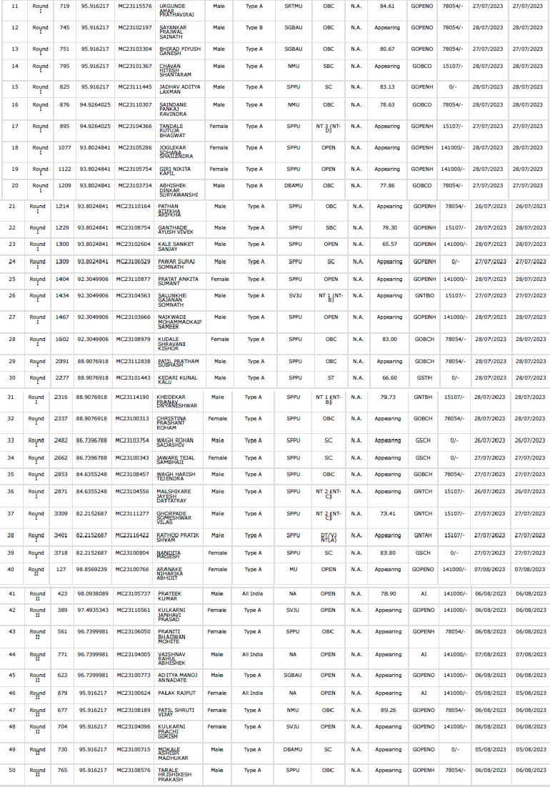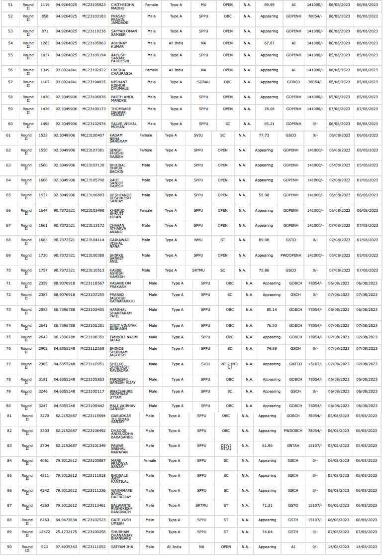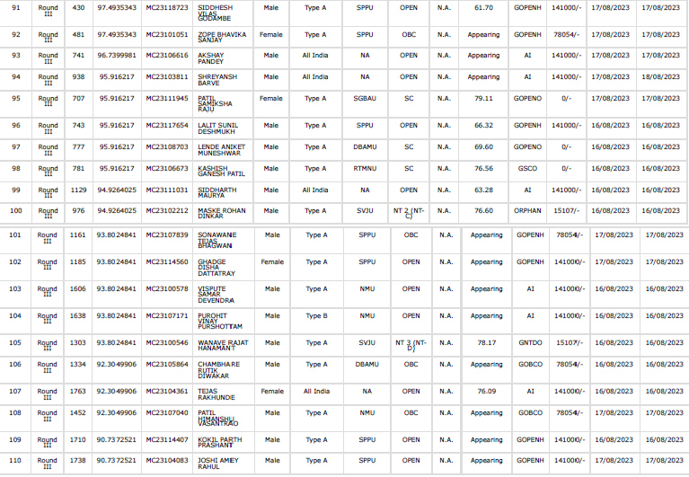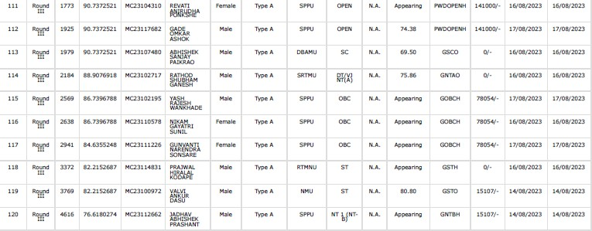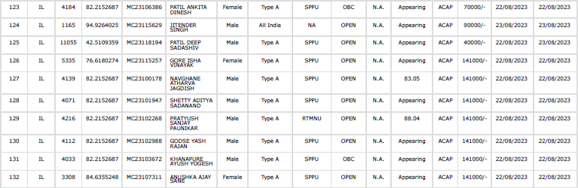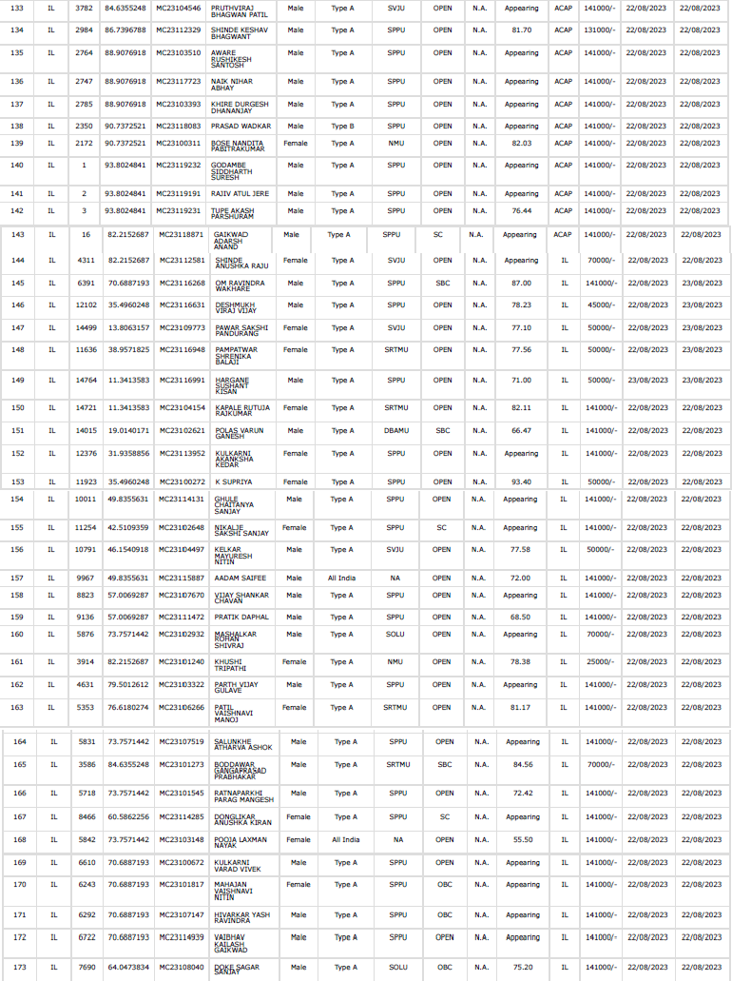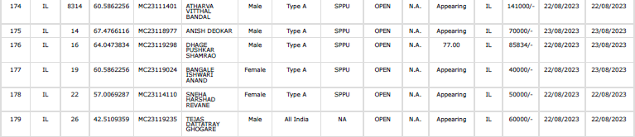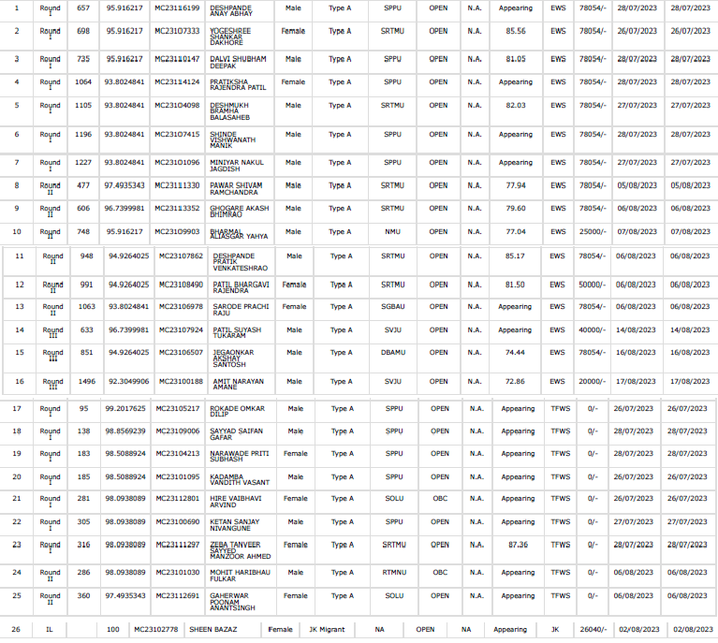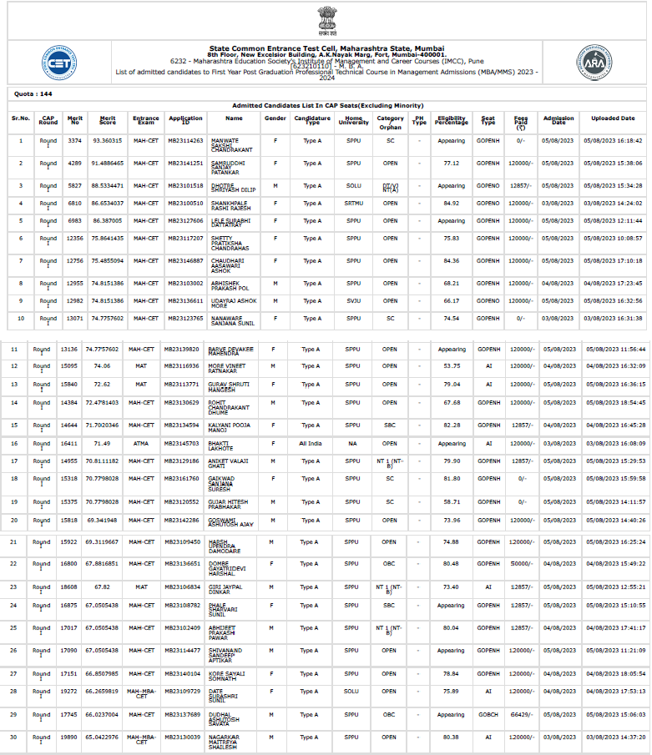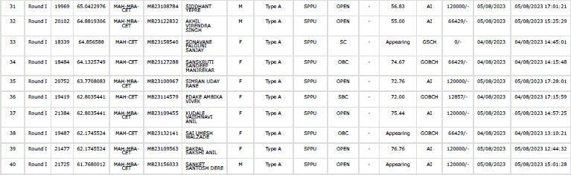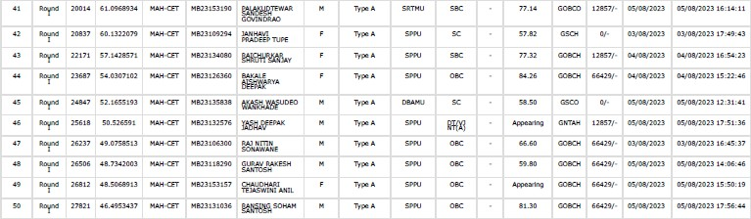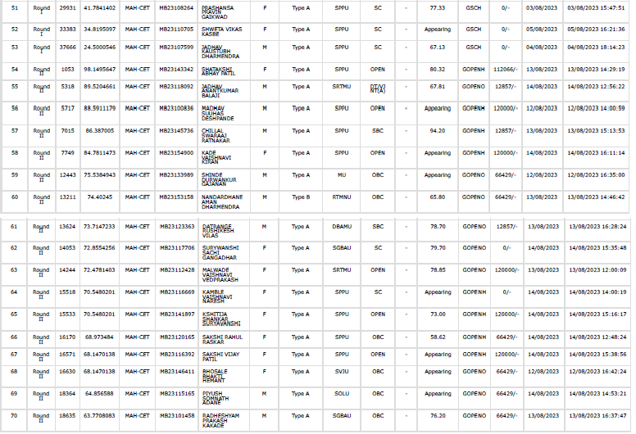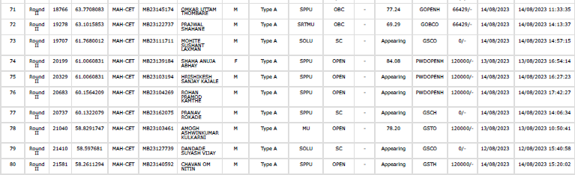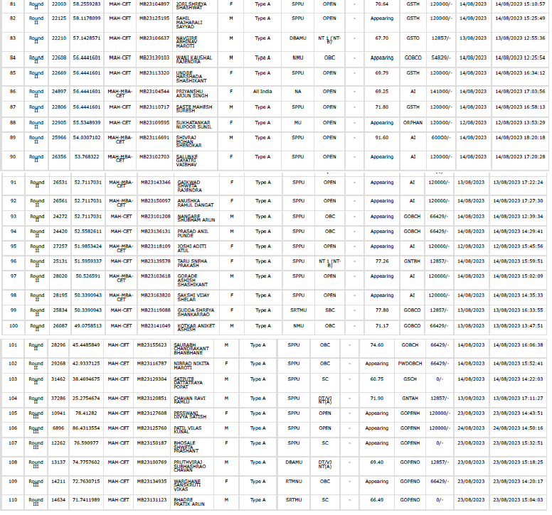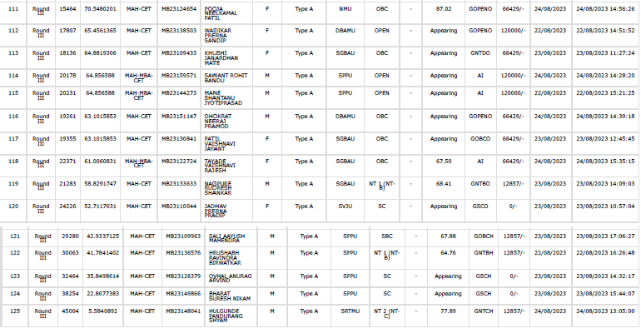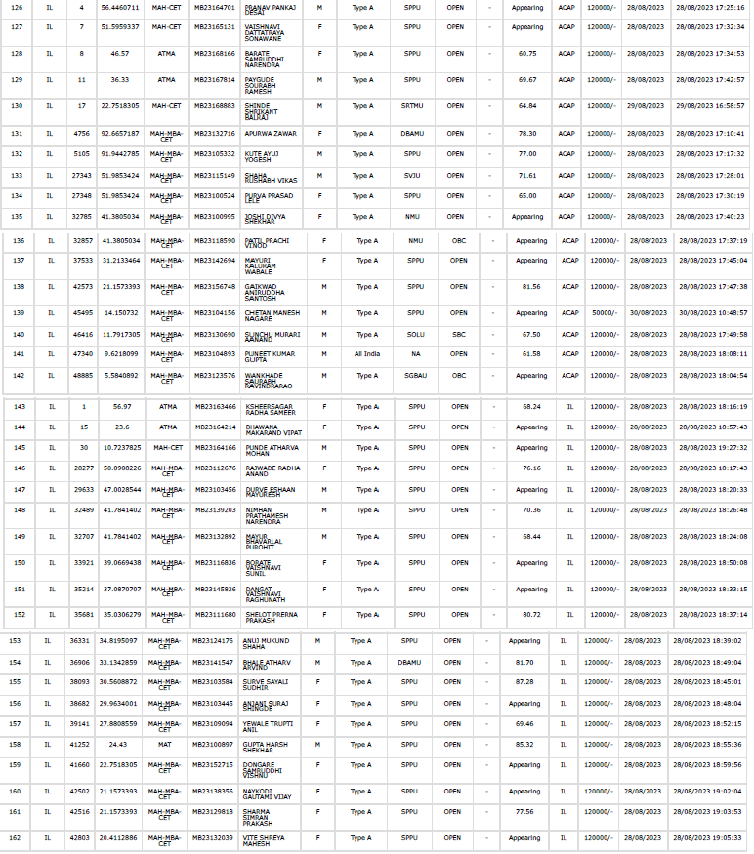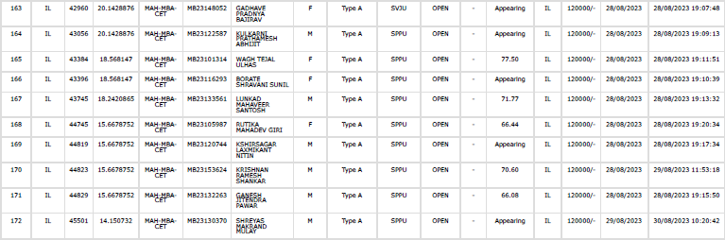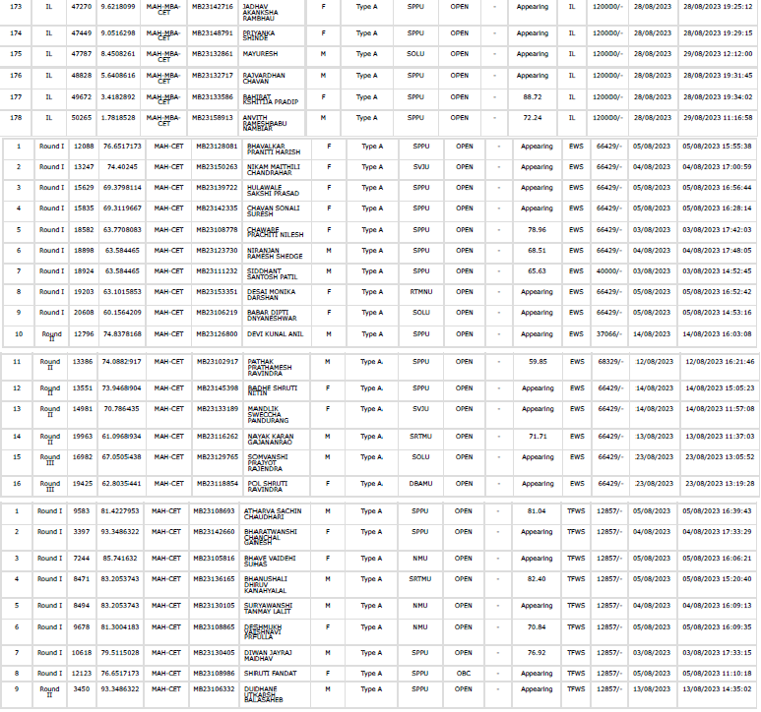

|  |  |  |
| --- | --- | --- |
|  |  | |
| **18.13** | **List of Applicants (MCA)** | As per State Common Entrance Cell, Maharashtra  State policy information brochure |

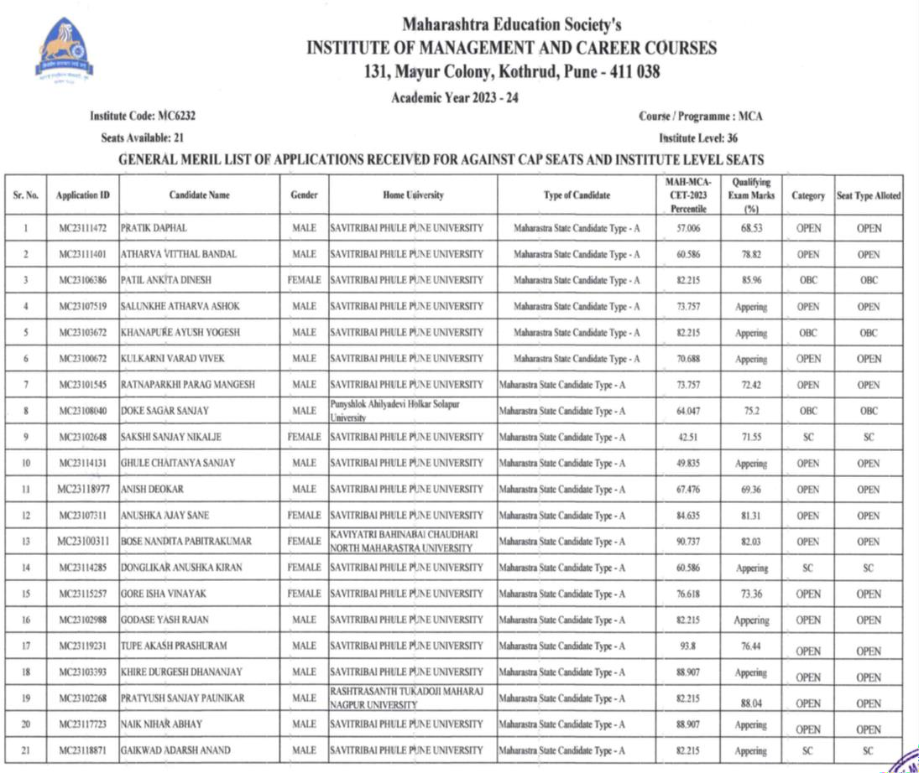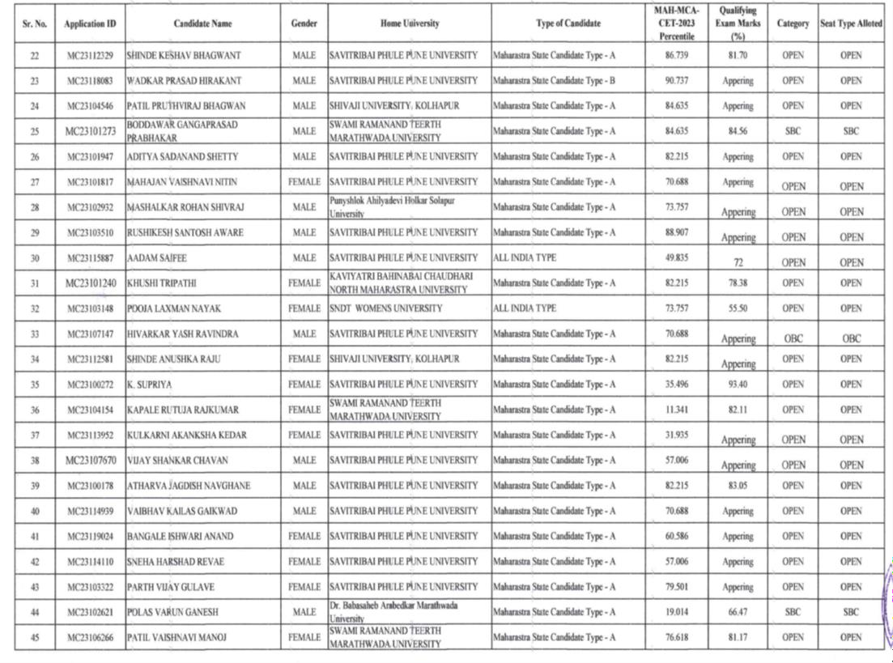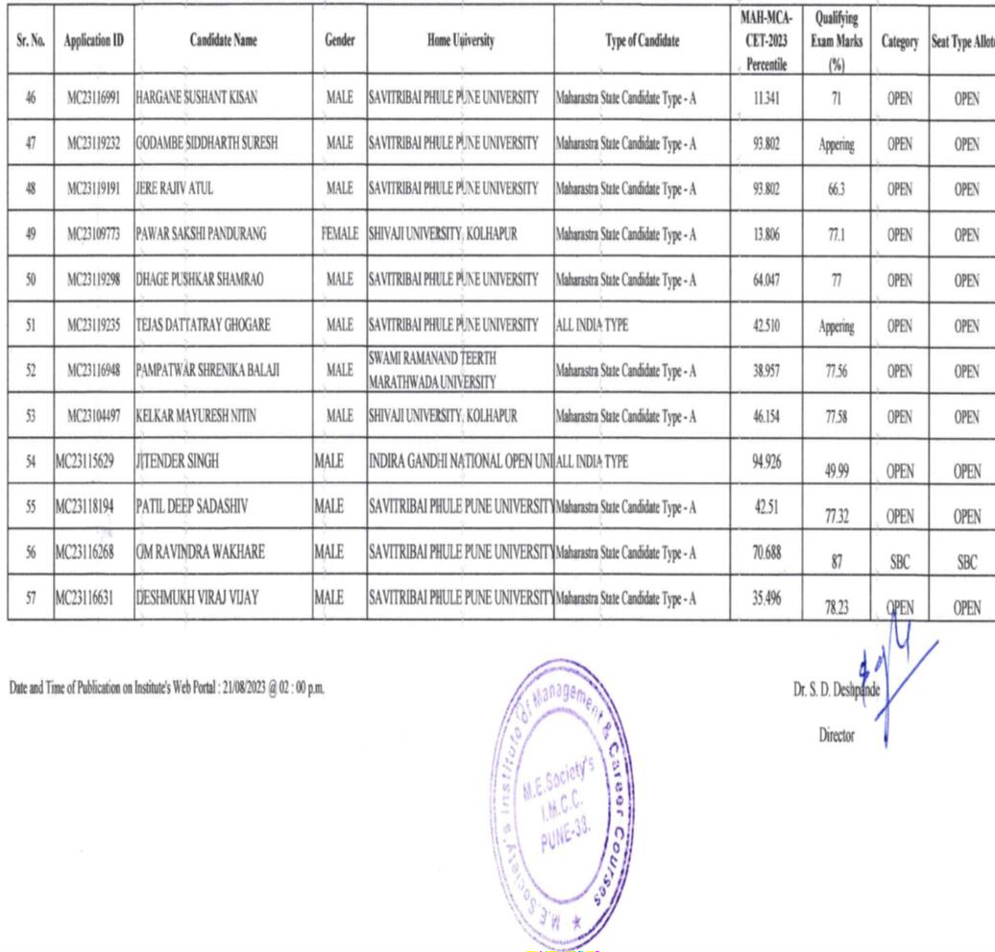

###### List of Applicants (MBA)

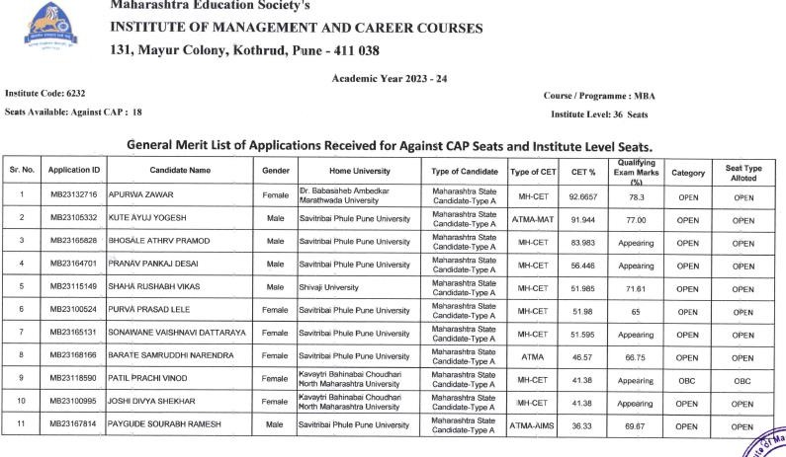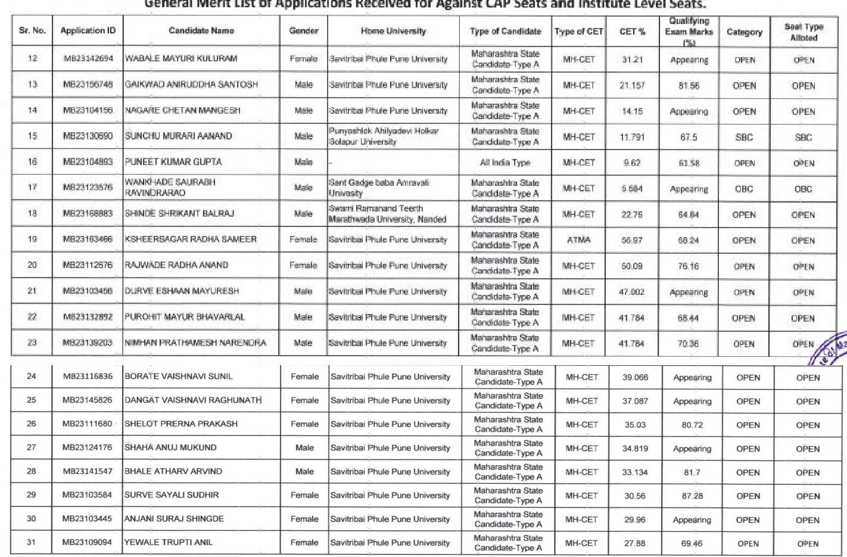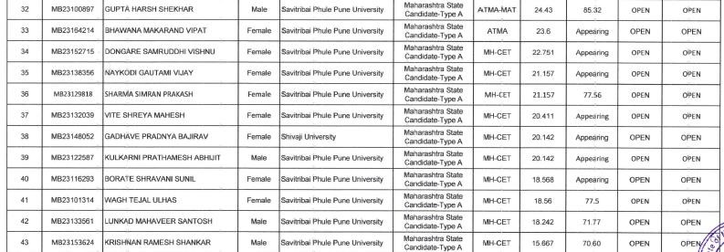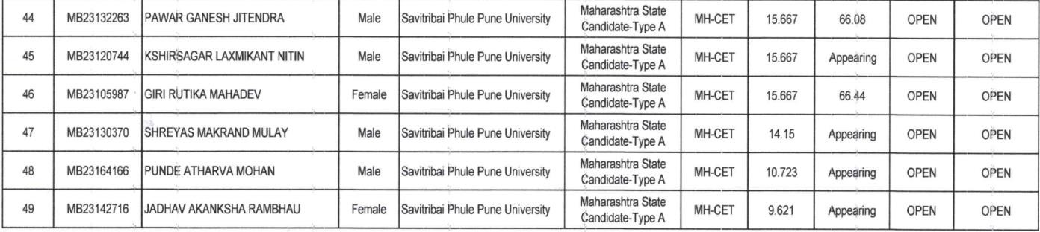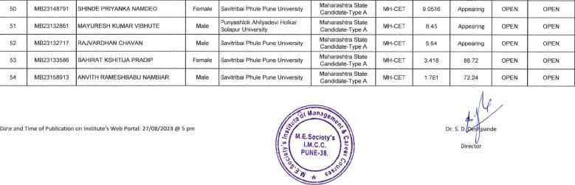

18.14

### Composition of Selection team for admission under Management Quota

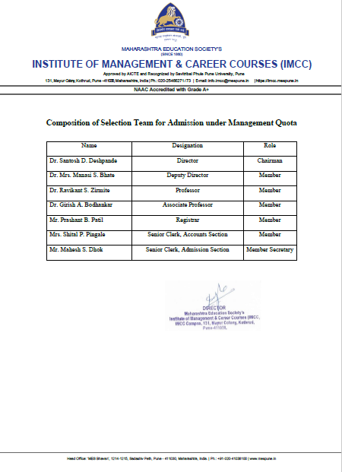

###### List of Candidate who have been offered admission

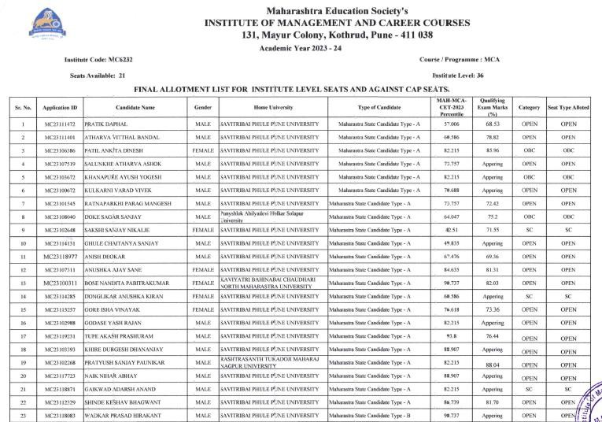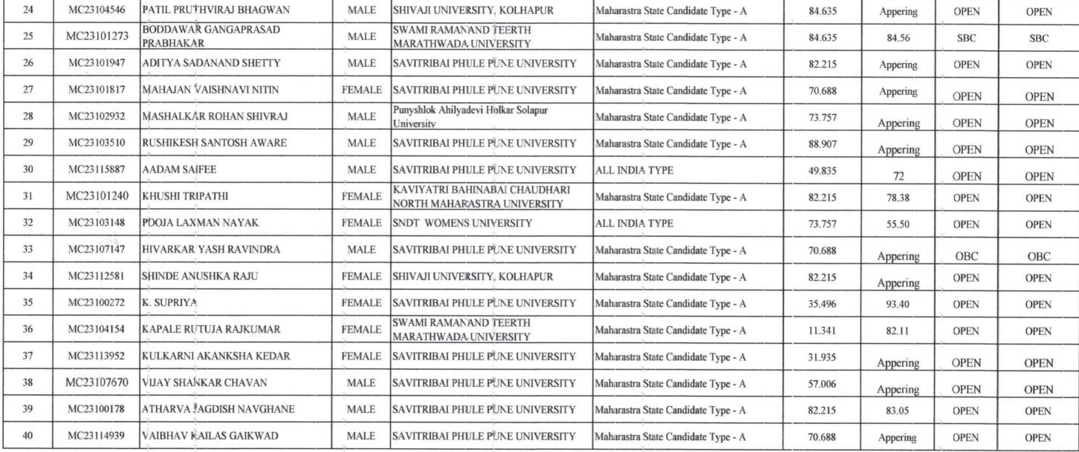

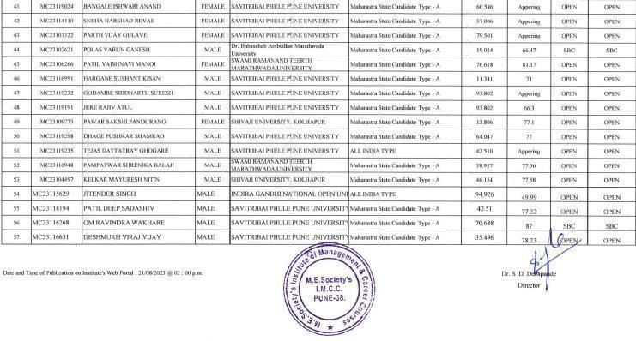

MBA- Candidate Selected on inter merit basis

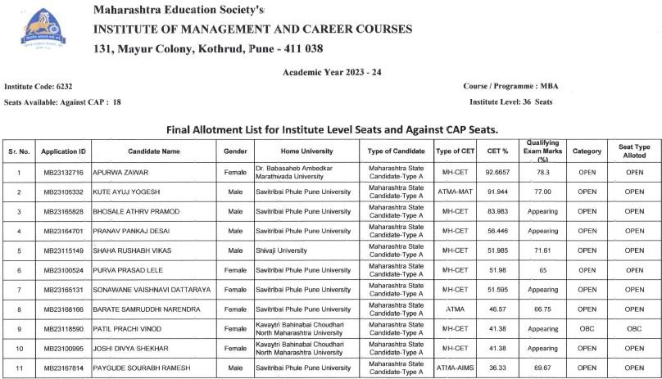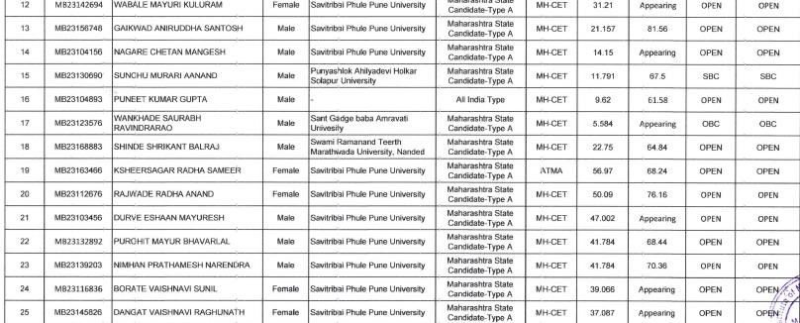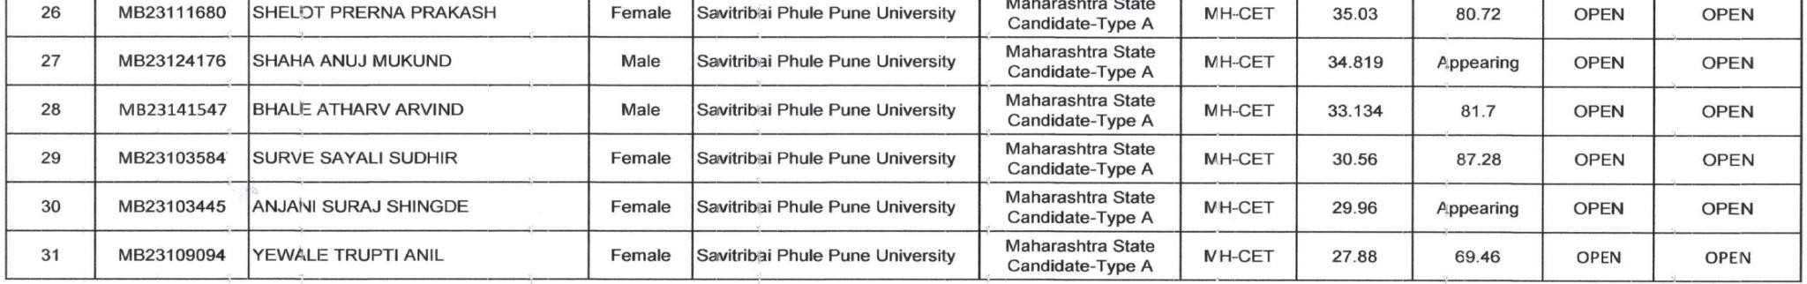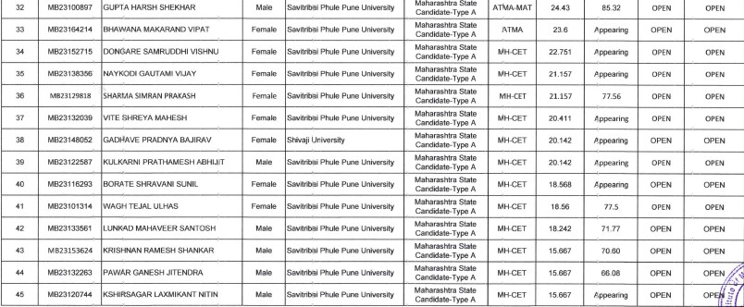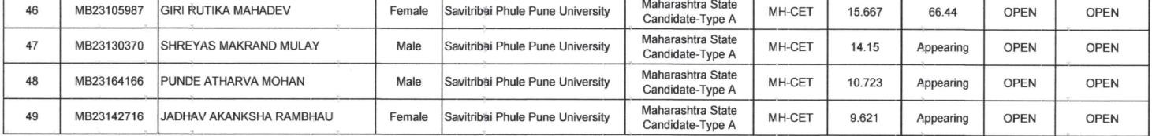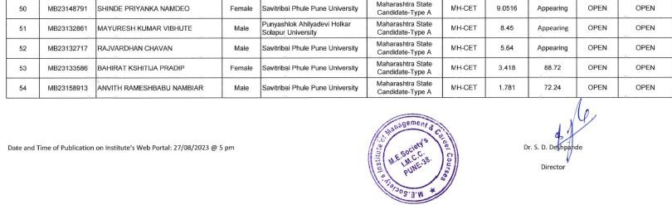

* 1. Waiting list of the candidate in order of merit to be operative from the last date of joining of the first list candidate: - NIL.

|  |  |  |  |
| --- | --- | --- | --- |
| **18.15** | **Information of Infrastructure and Other**  **Resources Available** | MCA | MBA |
| i. | Number of Class Rooms and size of each | 6 Nos. (76.81 Sq.m2 each) | 6 No. (75.04 Sq.m2 each) |
| ii. | Number of Tutorial rooms and size of each | 1.5 Nos.( 50 Sq.m2 ) | 1.5 Nos. (50 Sq.m2) |
| iii. | Number of Laboratories and size of each | 3 Nos. (198 Sq.m2 ) | NA |
| iv. | Number of Computer Centers with capacity of each | 1 No. (153 Sq.m2 ) | 1 No. (152.30 Sq.m2) |
| v. | Central Examination Facility, Number of rooms and capacity of each | 1 No. (30 Sq.m2 ) | |
| vi. | Online examination facility (Number of Nodes, Internet bandwidth, etc.) | Available: MCA : 128 PC, MBA : 128 PC  Internet Bandwidth Speed: 400 Mbps | |
| vii. | Barrier Free Built Environment for disabled and elderly persons | Lift, ramp, Toilet for disabled and elderly person available | |

|  |  |  |  |  |  |  |  |
| --- | --- | --- | --- | --- | --- | --- | --- |
| viii. | Fire and Safety Certificate | 1. Final Fire NOC Certificate No: FB/1078, Date: 05/07/2021.   2) Final Fire NOC Certificate No: FB/5013, Date: 22/03/2022. Above Certificates are issued by Pune Municipal Corporation Pune.   1. Form – B Certificate No. SSS/60/2023 -24, Date: 21/12/2023. Issued by Licensed Agency. | | | | | |
| ix. | Hostel Facilities. | Available. | | | | | |
| x. | Number of Library books/ e- books/Titles/ Journal available. (Programme- wise) | **Course Name** | **Library Books** | | | **Journal Print** | | |
| **Volumes** | | **Titles** |
| MCA | 81 | | 31 | 0 | | |
| MBA | 111 | | 32 | 0 | | |
| xi. | List of online National/ International  Journals subscribed: |  | | | **e-books** | | **e-Journal** |
| MCA | | | 35,00,000 (N- List, World E-Books Database, DELNET) | | 5197 (N-List, DELNET) |
| MBA | | | 6125 (N-List, Pro Quest) |
|  |  | | | | | | |
| xii. | National Digital Library (NDL) subscription details. | | | <https://imcc.mespune.in/infrastructure/library/> | | | |
| xiii. | List of Major Equipment / Facilities in each Laboratory MCA Programme    MBA Programme | | | | | | |

|  |  |  |  |
| --- | --- | --- | --- |
|  |  | | |
| xiv. | List of Experimental Setup in each Laboratory/ Workshop | | NA |
| xv. | Innovation Cell | Available | |
|  |  | | |

|  |  |  |
| --- | --- | --- |
|  | C:\Users\ADMIN\Desktop\Innovation Cell.JPG | |
| xvi. | **Social Media Cell** | **Yes.** |

|  |  |  |
| --- | --- | --- |
|  | C:\Users\ADMIN\Downloads\Social Media Cell_page-0001.jpg | |
| xvii. | Compliance of the Academy Bank of Credit (ABC) Applicable to  PGCM / PGDM Institutions and University Department | NA |
| xviii. | To upload the respective short video (1-2 min) of Infrastructure and facilities available w.r.t the course in the website. | https://www.youtube.com/watch?v=A4v6lrKAXW0 |
| xix. | Games and Sports | <https://imcc.mespune.in/events/sports/> |
|  |  | |
| xx. | Teaching Learning Process | Academic Planning and Implementation: It starts with academic calendar preparation coherent with the university curriculum. Subject allotment is done by the Head of the  Department based on the subject expertise of each faculty. |

|  |  |  |  |  |  |  |  |
| --- | --- | --- | --- | --- | --- | --- | --- |
|  |  | Industry input from the experts is considered in designing and implementation of Open Course(s). Class-wise timetable is prepared and disseminated. As an integral part of teaching learning methodology, each faculty prepares a course file, teaching plan and lecture execution plan considering various aspects of course delivery pedagogy. Every course file includes course objectives, syllabus, teaching plan, course outcomes, program outcomes, list of text books and reference books and other reference material if required. The Head of the Department and Program Coordinator together follow the execution of academics via Academic meetings.  Course delivery: Institute has smart classrooms having ICT facilities which complement the teaching learning process. Effective course delivery is achieved through demonstrations, video lectures, role play and other techniques. In addition, different online facilities such as NPTEL, MOOC, Coursera, Swayam are provided to the students. By actively involving students in the teaching-learning process, the Institute has succeeded in shifting the course delivery process from being ‘teacher-centric’ to being ‘student-centric’. Extensive use of Learning Management Systems (LMSs), other e-resources is done innovatively. Page 25/116 14-02-2023 02:21:01 Self Study Report of Maharashtra Education Society's Institute of Management and Career Courses Students feedback on the course delivery is taken regularly. Effective curriculum delivery is ensured through guest lectures, seminars, expert sessions, industry visits, project guidance, technical workshops, soft skills training, execution of Open Courses, etc imparted by Industry resources. The success of above endeavors and additional training is evident from exemplary academic success and competent placements. Continuous Internal Assessment: Well-planned continuous internal assessment is properly documented and disseminated to  students through the ‘Internal Concurrent Evaluation’ manual. In addition to Mid-term and Term-end assessments which are conducted within every semester various innovative assessment methods are implemented for each course. To gauge understanding level of every course by the  students, regular assignments and tutorials are uploaded on LMS to be duly submitted by the students. | | | | | |
| xxi. | For each Post Graduate Courses give the following |  | | | | | |
| xxii. | Title of the Course | 1. Master In Computer Applications. 2. Master In Business Administration. | | | | | |
| xxiii. | Laboratory Facilities exclusive to the Post Graduate Course |  | | | | | |
| **Master In Computer Applications**    **Master In Business Administration** | | | | | | |
| 18.16 | Enrolment and placement details of students in the last 3 year | **MCA**  **(A.Y. 2021 – 22)** | | **MCA (A.Y. 2022 – 23)** | | **MCA**  **(A.Y. 2023 – 24)** | |
| Enrolment | Placement | Enrolment | Placement | Enrolment | Placement |
|  | Enrolment and placement details | 219 | 111 | 180 | 55 | 180 | 28 |
| Minimum Salary |  | 1.2 Lacs |  | 1.5 Lacs |  | 1.8 Lacs |
| Maximum Salary |  | 5.5 Lacs |  | 6.0 Lacs |  | 8.0 Lacs |
| Average Salary |  | 2 Lacs |  | 3.75 Lacs |  | 4.9 Lacs |
|  | | | | | | |
| Enrolment and placement details of students in the last 3 year | **MBA**  **(A.Y. 2021 – 22)** | | **MBA (A.Y. 2022 – 23)** | | **MBA**  **(A.Y. 2023 – 24)** | |
|  |  | Enrolment | Placement | Enrolment | Placement | Enrolment | Placement |
|  | Enrolment and placement details | 60 | 52 | 60 | 45 | 180 | 96 |
|  | Minimum Salary |  | 1.2 Lacs |  | 1.0 Lacs |  | 1.0 Lacs |
|  | Maximum Salary |  | 4.5 Lacs |  | 5.5 Lacs |  | 6.0 Lacs |
|  | Average Salary |  | 2 Lacs |  | 3.25 Lacs |  | 3.5 Lacs |
| 18.17 | List of Research, Project/Consultancy, Work List of Research, Project/Consultancy Work | <https://imcc.mespune.in/research/research->[projects/](https://imcc.mespune.in/research/research-projects/) | | | | | |
| 18.18 | MOUs with Industries | <https://imcc.mespune.in/training-and-placement/mous/> | | | | | |